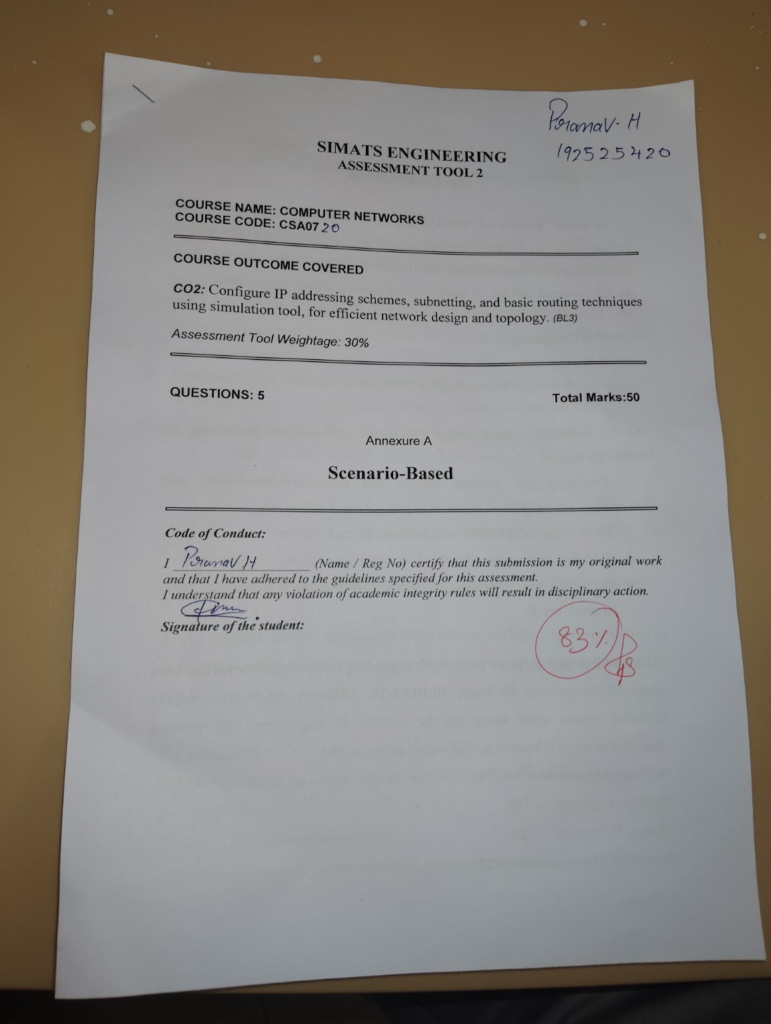
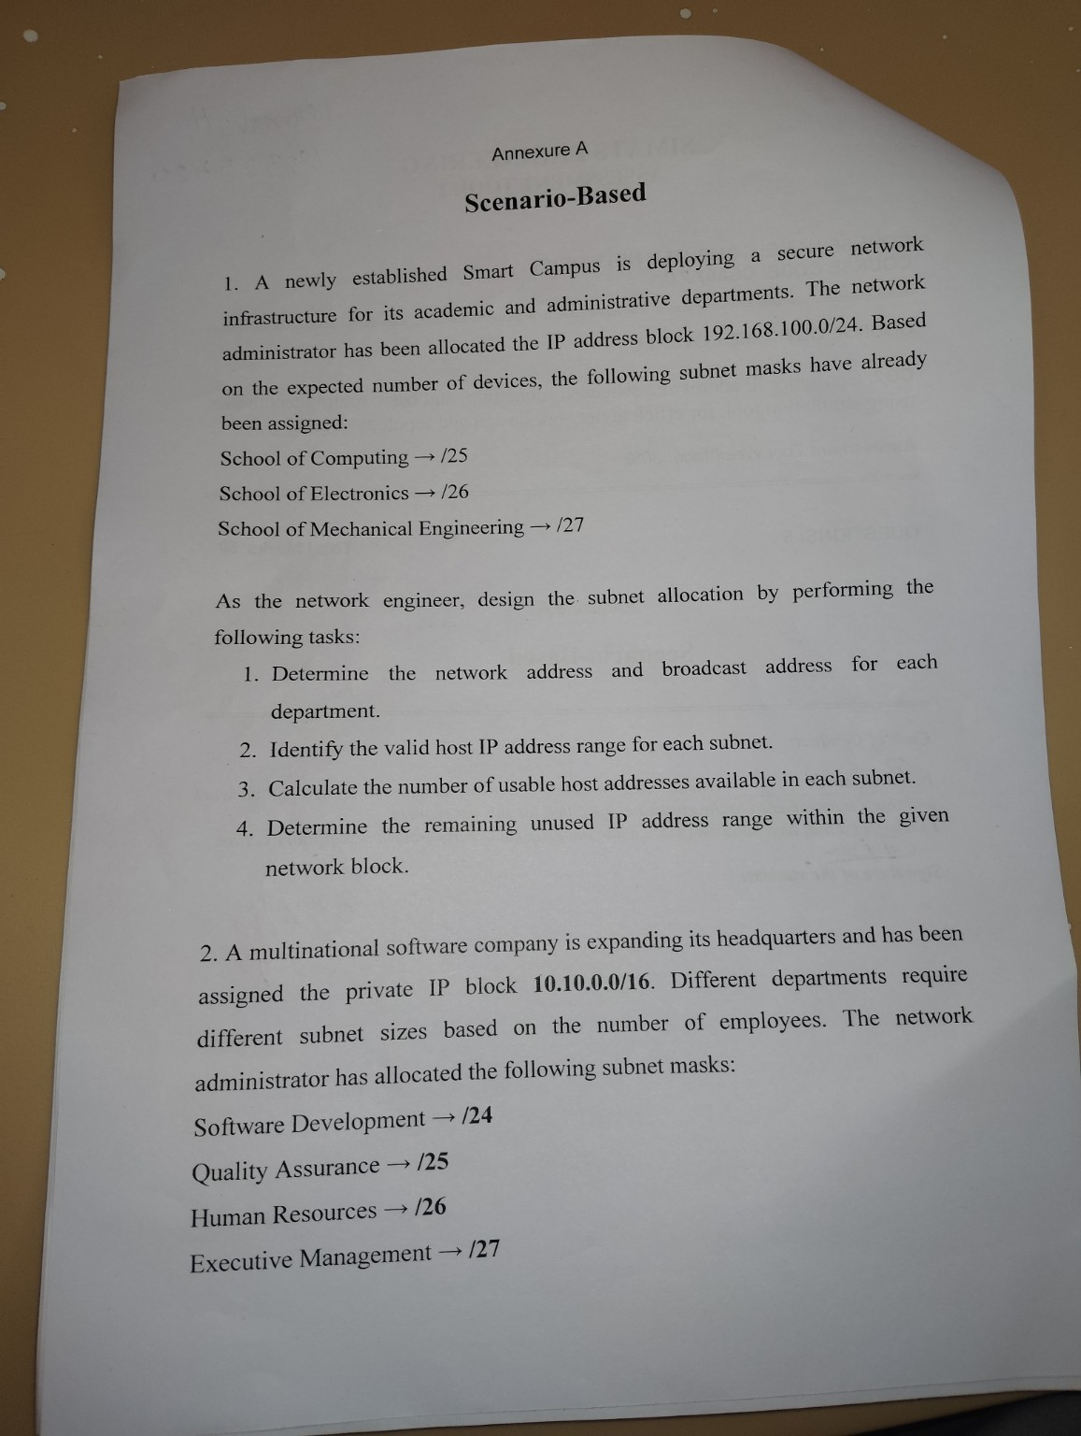
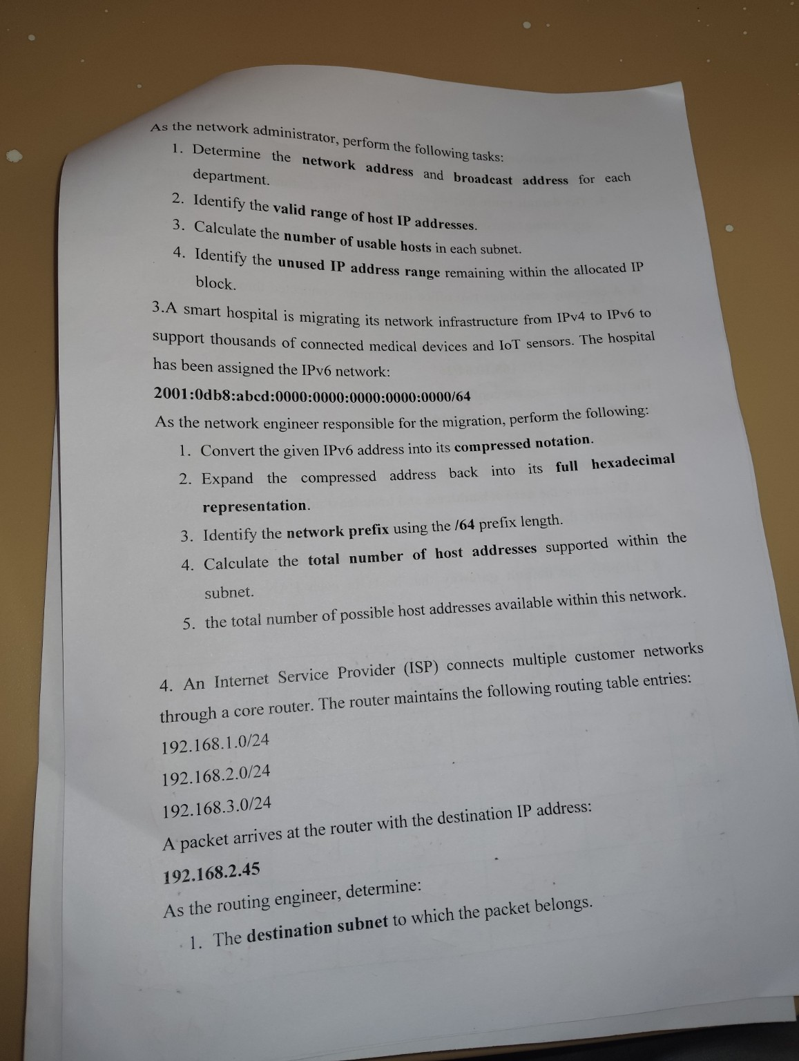
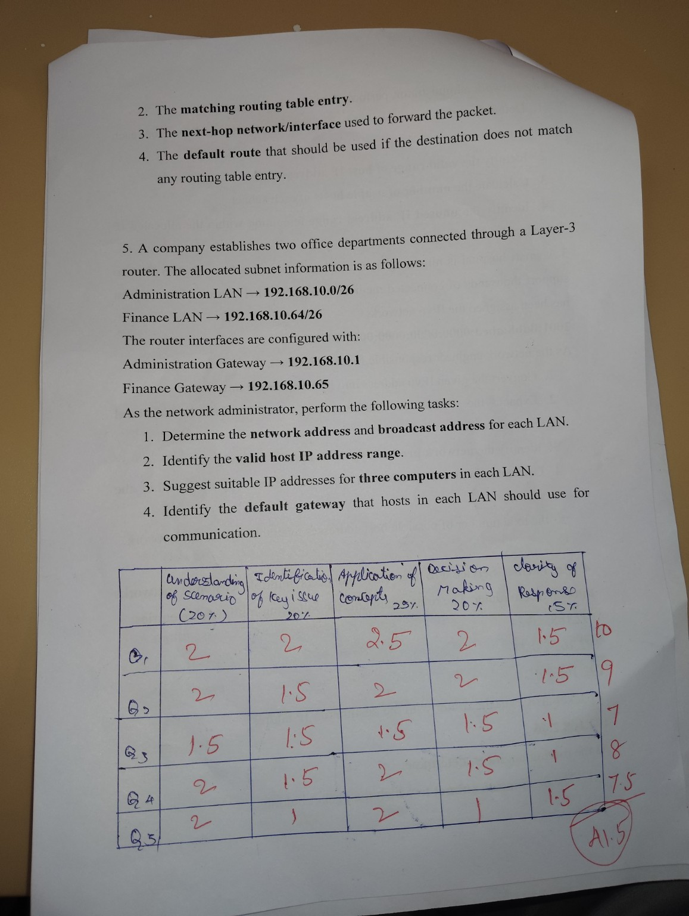
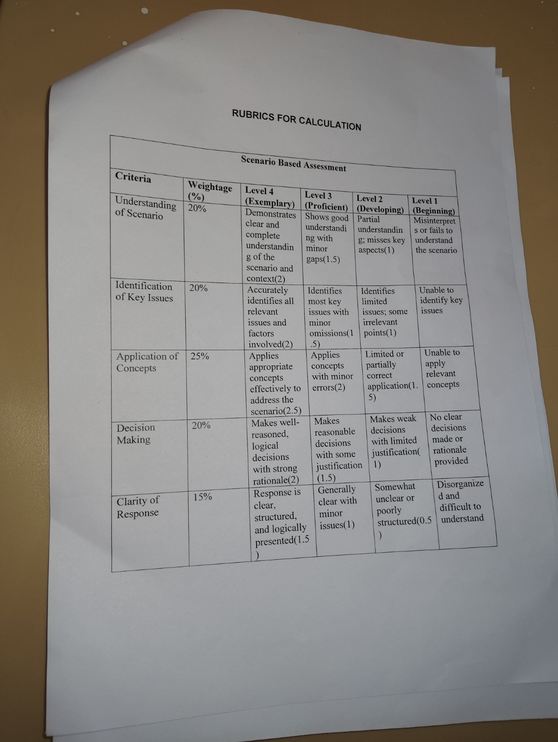
SIMATS ENGINEERING
ASSESSMENT TOOL 2

COURSE NAME: COMPUTER NETWORKS
COURSE CODE: CSA07

COURSE OUTCOME COVERED

CO2: Configure IP addressing schemes, subnetting, and basic routing techniques using simulation tool, for efficient network design and topology. (BL3)

Assessment Tool Weightage: 30%

QUESTIONS: 5 Total Marks:50

Annexure A

Scenario-Based

Code of Conduct:

I ____________________ (Name / Reg No) certify that this submission is my original work and that I have adhered to the guidelines specified for this assessment.
I understand that any violation of academic integrity rules will result in disciplinary action.

Signature of the student:

Annexure A

Scenario-Based

1. A newly established Smart Campus is deploying a secure network infrastructure for its academic and administrative departments. The network administrator has been allocated the IP address block 192.168.100.0/24. Based on the expected number of devices, the following subnet masks have already been assigned:
School of Computing → /25
School of Electronics → /26
School of Mechanical Engineering → /27

As the network engineer, design the subnet allocation by performing the following tasks:
- Determine the network address and broadcast address for each department.
- Identify the valid host IP address range for each subnet.
- Calculate the number of usable host addresses available in each subnet.
- Determine the remaining unused IP address range within the given network block.

Answer:
School of Computing (/25): Network address = 192.168.100.0, Broadcast address = 192.168.100.127.
School of Electronics (/26): Network address = 192.168.100.128, Broadcast address = 192.168.100.191.
School of Mechanical Engineering (/27): Network address = 192.168.100.192, Broadcast address = 192.168.100.223.
Valid host IP address range:
School of Computing: 192.168.100.1 to 192.168.100.126
School of Electronics: 192.168.100.129 to 192.168.100.190
School of Mechanical Engineering: 192.168.100.193 to 192.168.100.222
Number of usable host addresses:
School of Computing (/25): 126 usable hosts
School of Electronics (/26): 62 usable hosts
School of Mechanical Engineering (/27): 30 usable hosts
Remaining unused IP address range:
192.168.100.224 to 192.168.100.255 (a block of 32 addresses, equivalent to a /27 subnet) remains unused and available for future allocation.

2. A multinational software company is expanding its headquarters and has been assigned the private IP block 10.10.0.0/16. Different departments require different subnet sizes based on the number of employees. The network administrator has allocated the following subnet masks:
Software Development → /24
Quality Assurance → /25
Human Resources → /26
Executive Management → /27
As the network administrator, perform the following tasks:
- Determine the network address and broadcast address for each department.
- Identify the valid range of host IP addresses.
- Calculate the number of usable hosts in each subnet.
- Identify the unused IP address range remaining within the allocated IP block.

Answer:
Software Development (/24): Network address = 10.10.0.0, Broadcast address = 10.10.0.255.
Quality Assurance (/25): Network address = 10.10.1.0, Broadcast address = 10.10.1.127.
Human Resources (/26): Network address = 10.10.1.128, Broadcast address = 10.10.1.191.
Executive Management (/27): Network address = 10.10.1.192, Broadcast address = 10.10.1.223.
Valid range of host IP addresses:
Software Development: 10.10.0.1 to 10.10.0.254
Quality Assurance: 10.10.1.1 to 10.10.1.126
Human Resources: 10.10.1.129 to 10.10.1.190
Executive Management: 10.10.1.193 to 10.10.1.222
Number of usable hosts:
Software Development (/24): 254 usable hosts
Quality Assurance (/25): 126 usable hosts
Human Resources (/26): 62 usable hosts
Executive Management (/27): 30 usable hosts
Unused IP address range remaining:
After allocating the four subnets, the block from 10.10.1.224 to 10.10.255.255 remains unused within the 10.10.0.0/16 allocation and is available for future departments.

3.A smart hospital is migrating its network infrastructure from IPv4 to IPv6 to support thousands of connected medical devices and IoT sensors. The hospital has been assigned the IPv6 network:
2001:0db8:abcd:0000:0000:0000:0000:0000/64
As the network engineer responsible for the migration, perform the following:
- Convert the given IPv6 address into its compressed notation.
- Expand the compressed address back into its full hexadecimal representation.
- Identify the network prefix using the /64 prefix length.
- Calculate the total number of host addresses supported within the subnet.
- the total number of possible host addresses available within this network.

Answer:
Compressed notation: 2001:db8:abcd::/64
Full hexadecimal (expanded) representation: 2001:0db8:abcd:0000:0000:0000:0000:0000
Network prefix (/64): The first 64 bits, 2001:0db8:abcd:0000, form the network prefix, written as 2001:0db8:abcd:0000::/64. The remaining 64 bits are used for the interface identifier (host portion).
Total number of host addresses supported: With a /64 prefix, 64 bits remain for host addressing, giving 2^64 = 18,446,744,073,709,551,616 possible addresses.
Total number of possible host addresses available within this network: This is the same as above, 2^64 (approximately 1.8 x 10^19) usable interface addresses, since IPv6 does not reserve a separate broadcast address.

4. An Internet Service Provider (ISP) connects multiple customer networks through a core router. The router maintains the following routing table entries:
192.168.1.0/24
192.168.2.0/24
192.168.3.0/24
A packet arrives at the router with the destination IP address:
192.168.2.45
As the routing engineer, determine:
- The destination subnet to which the packet belongs.
- The matching routing table entry.
- The next-hop network/interface used to forward the packet.
- The default route that should be used if the destination does not match any routing table entry.

Answer:
Destination subnet: The packet's destination 192.168.2.45 falls within the 192.168.2.0/24 subnet (valid host range 192.168.2.1 - 192.168.2.254).
Matching routing table entry: 192.168.2.0/24 is the entry that matches the destination address.
Next-hop network/interface: The router forwards the packet out of the interface configured for the 192.168.2.0/24 network (the interface directly connected to that subnet).
Default route: If the destination does not match any entry in the table, the router uses the default route 0.0.0.0/0, which forwards the packet to the gateway of last resort (the ISP's upstream link).

5. A company establishes two office departments connected through a Layer-3 router. The allocated subnet information is as follows:
Administration LAN → 192.168.10.0/26
Finance LAN → 192.168.10.64/26
The router interfaces are configured with:
Administration Gateway → 192.168.10.1
Finance Gateway → 192.168.10.65
As the network administrator, perform the following tasks:
- Determine the network address and broadcast address for each LAN.
- Identify the valid host IP address range.
- Suggest suitable IP addresses for three computers in each LAN.
- Identify the default gateway that hosts in each LAN should use for communication.

Answer:
Administration LAN (192.168.10.0/26): Network address = 192.168.10.0, Broadcast address = 192.168.10.63.
Finance LAN (192.168.10.64/26): Network address = 192.168.10.64, Broadcast address = 192.168.10.127.
Valid host IP address range:
Administration LAN: 192.168.10.1 to 192.168.10.62
Finance LAN: 192.168.10.65 to 192.168.10.126
Suggested IP addresses for three computers in each LAN:
Administration LAN: 192.168.10.2, 192.168.10.3, 192.168.10.4
Finance LAN: 192.168.10.66, 192.168.10.67, 192.168.10.68
Default gateway for each LAN:
Administration LAN hosts use 192.168.10.1 as the default gateway.
Finance LAN hosts use 192.168.10.65 as the default gateway.

RUBRICS FOR CALCULATION

Scenario Based Assessment
Criteria | Weightage (%) | Level 4 (Exemplary) | Level 3 (Proficient) | Level 2 (Developing) | Level 1 (Beginning)
Understanding of Scenario | 20% | Demonstrates clear and complete understanding of the scenario and context(2) | Shows good understanding with minor gaps(1.5) | Partial understanding; misses key aspects(1) | Misinterprets or fails to understand the scenario
Identification of Key Issues | 20% | Accurately identifies all relevant issues and factors involved(2) | Identifies most key issues with minor omissions(1.5) | Identifies limited issues; some irrelevant points(1) | Unable to identify key issues
Application of Concepts | 25% | Applies appropriate concepts effectively to address the scenario(2.5) | Applies concepts with minor errors(2) | Limited or partially correct application(1.5) | Unable to apply relevant concepts
Decision Making | 20% | Makes well-reasoned, logical decisions with strong rationale(2) | Makes reasonable decisions with some justification(1.5) | Makes weak decisions with limited justification(1) | No clear decisions made or rationale provided
Clarity of Response | 15% | Response is clear, structured, and logically presented(1.5) | Generally clear with minor issues(1) | Somewhat unclear or poorly structured(0.5) | Disorganized and difficult to understand

